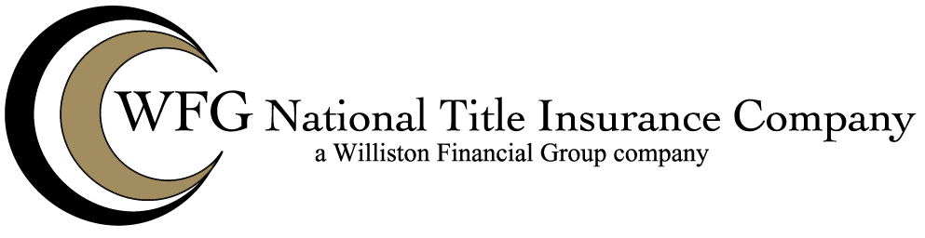

Attached to Policy No. __________
Issued By
WFG NATIONAL TITLE INSURANCE COMPANY

The Company hereby insures against loss or damage incurred by reason of the enforcement or attempted enforcement of the mechanics lien shown in Item__, Schedule B.

This endorsement is issued as part of the policy. Except as it expressly states, it does not (i) modify any of the terms and provisions of the policy, (ii) modify any prior endorsements (iii) extend the Date of Policy, or (iv) increase the Amount of Insurance. To the extent a provision of the policy or a previous endorsement is inconsistent with an express provision of this endorsement, this endorsement controls. Otherwise, this endorsement is subject to all of terms and provisions of the policy and of prior endorsements.

WFG NATIONAL TITLE INSURANCE COMPANY

By: ______________________________
Authorized Signatory

